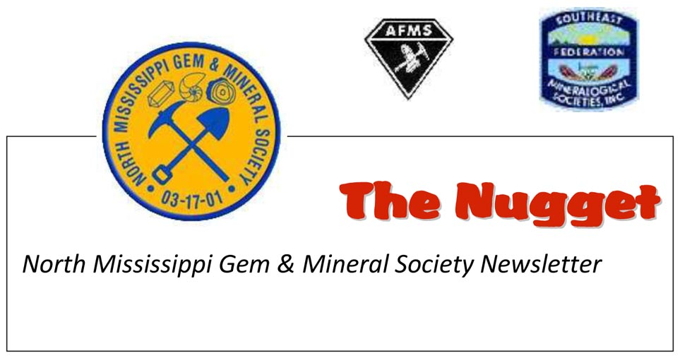
Volume 14 Issue 9 March 11, 2015
www.nmgms.org

Notes from the President’s Desk….February 2015
Happy Valentine’s’ Day! Well, it looks like we’re facing 6 more weeks of winter, since Punxsutawney Phil saw his shadow, but if they’re as busy and fun as the first 6, then that’s ok with me. NMGMS opened the year with a great January. Once again, Dr. Terry Panhorst packed a full house at our Jan. 17th meeting, where he presented his discussion on present day gold mining operations. Terry’s programs are always very well done and informative. Gives us all a chance to absorb a little bit of college geology and have some fun too. Thank you Terry; we appreciate it immensely!
Despite the subfreezing temperatures, we had a great turnout for our January 10th field trip. Hey, a little ice never stopped a dedicated and intrepid fossil collector! Besides, the sun came out, the wind died, and we all had a great day. Thanks to APS for coming out and joining us on that excursion. It always helps to have a few “experts” on hand to identify what you’re collecting.
Our last January activity was the greatly anticipated Kim St. Jean- Mixed Metals class, held at the Women First Center in Tupelo on Jan. 24th. Again, like last year, Kim was teaching to a full class of NMGMS members. Check out Clarice’s review of the class and the accompanying photos for more details. We can’t say enough about how appreciative we are that Kim and her husband, Norm, take the time from their trip out to Tucson, to stop here and do these classes for us. NMGMS is so fortunate to have the opportunity to offer a class like this, and also, we thank the Women First Center for providing us with the perfect location for hosting it. So, at the March “show and tell” we should see some great creations!
February looks like it is going to be just as packed full of fun and exciting activities for NMGMS, as January was. There’s the Rockheads field trip to the Pink Palace on the 7th and then a copper bangle workshop for our club members on Feb. 14th. The program at our Feb. 21st meeting is going to be a “heart” themed lapidary project involving wire and beads. So be sure and mark your calendars and don’t miss out on the fun and learning. When marking these events on your calendar, don’t forget to make a note of the Jackson, MS MGMS rock and gem show coming up on Feb. 28th and March 1st, and the MMNS Fossil Road Show at the museum in Jackson, scheduled for March 7, 2015.
With all of these events coming up, I wish to encourage everyone to be sure and get your 2015 membership up to date, so that all participants are covered by the federation insurance that we carry. Our insurance is due to be renewed with the SFMS by the end of March. Right now, there are 64 NMGMS members on the new 2015 roster. We had 114 at the end of last year, so there are still many of you out there, who need to renew. Please consider all that NMGMS has to offer; all of our members are important to our organization and make it the great society that it is. We hope that you’ll consider staying a part of the NMGMS family. Nancy Roberts

Page 1 NMGMS PO Box 1445 Tupelo, MS 38802
The Nugget: Volume 14 Issue 9
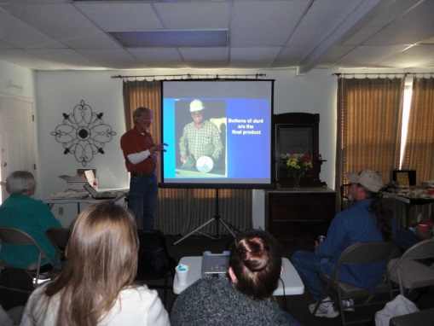
Modern Gold Mining Methods Explained

At our Jan. 17th meeting, Dr. Terry Panhorst, with the Geology Dept. at the University of Miss., presented a very in depth explanation of how gold is mined today. His slide presentation on hard rock mining, showed everything from the blasting of the bedrock to the leaching and collecting processes used in the mining of the native element, gold. With today's modern methods, mining operations can go back to sites, where the gold rich veins had been played out by the "49ers", and extract the gold from the remaining bedrock, where concentrations are high enough to make it worthwhile. By using plastic liners, chemicals. collecting basins, filters, electroplating(electrowinning), and smelting, gold can be "harvested" from the earth, where panning and sluicing are no longer the way to go.
Thank you Terry for another great presentation!
Nancy Roberts
Photo by Nancy Roberts

Mark Your Calendar!
NMGMS February Meeting Notice
Since the Lee County Public Library's auditorium was unavailable on Feb. 21st, our February meeting will be from 1 to 3p.m. at the Women First Center, 215 N Gloster Suite D, in Tupelo on Saturday Feb. 21, 2015. It is not very far at all from the library and is on the west side of Gloster, between the traffic light on Main and the light at Jefferson. Watch for the NMGMS sign near the curb. The program will be a wire wrapped heart project. We’ll be working with wire and beads and this will be lots of fun for all ages.

March Field Trip to Missouri:

For our March 7-8th field trip, we will be collecting agate rocks/boulders/chips covered in drusy quartz in the Mark Twain National Forest area near Potosi MO. Local area resident, Betty Marler will be our field guide. We will rendezvous at 8:30 a.m. Saturday, March 7th, at the Hardees on Hwy 67, just a mile or so south of Rosener's Motor Lodge, where I have reserved rooms for us.
Equipment for the dig: gloves, shovels, pry bars, small rake, hammer and chisel, buckets and possibly a small cart, wagon, wheel barrow or a sled or other flat bottomed device that can be pulled with a rope for hauling out larger pieces! :) Many of the bigger and more interesting pieces may be partially buried, so expect to do some digging. This is an old strip mine area. The smaller pieces, especially those that can be used for jewelry, are scattered all over the ground, especially around the trees. Plan on a big haul; last time, the back of my truck was full!! Jim and I carried the full buckets to the truck, dumped the rocks into big cardboard boxes, and then went back for more!! Let's hope for a sunny day, because when the drusy sparkles it's easy to spot and collect!! BTW, we'll be out in the woods and there are no facilities, so pack a lunch, drinks, snacks and some TP!!

Page 2 NMGMS PO Box 1445 Tupelo, MS 38802
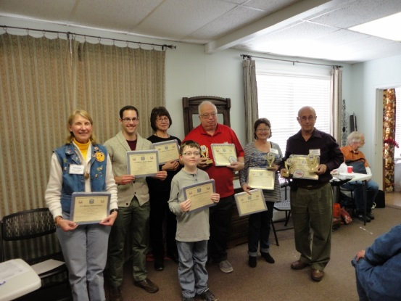
NMGMS Members Receive SFMS 2014 Bulletin Competition Awards The Nugget: Volume 14 Issue 9
At the Jan. 17, 2015 NMGMS meeting, the awards and certificates from the 2014 SFMS Bulletin Competition were handed out to the winners.
Here are the standings:
Small Bulletins, 2nd place, The Nugget, Dana Jones, editor
Large Bulletins, 2nd place, MAGS Rockhound News, Matthew Lybanon, editor
Original adult articles, 1st place, Matthew Lybanon
Written features, 1st place, John Byzet, 2nd place tie, Clarice Turner and Carol Lybanon
4th place, Nancy Roberts, 5th place Jake Carr and 6th place, Justin Hobart.
Congratulations and great job NMGMS!! Photo by Mike Schuchs

Rockheads: January 2015
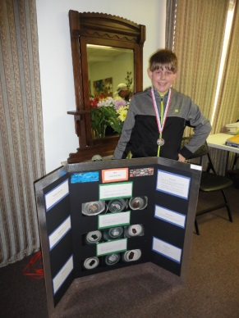
Congratulations Rockhead Konrad!

NMGMS junior member, Konrad Armstrong, took a first place at his school's science fair with his project based upon the effects of freezing on the three groups of rocks: igneous, sedimentary and metamorphic. He will go on to the regionals. Kudos Konrad!!
Photo by Nancy Roberts

The NMGMS Rockheads' Jan. 17, 2015 meeting.
Attendance: Robin and Victoria Langford, Matthew and Brittani Lambert, and Jake, Marion and Alice Carr

We are going to make pottery out of clay. We made clay pots, vases and a bunch of other stuff. We earned some badges. Brittani Lambert, Secretary

As the Rockheads embarked on their journey to earning badges, they had a chance to earn one today. On this day, they made pots and bowls out of pieces of clay to resemble the appearance of artifacts for the Stone Age Tools and Arts badge. I would like to say, that personally as a Rockhead and a teenager, in looking at young kids taking the initiative and enjoying what they do; keep it up and you'll be good Rockheads in the future. Matthew Lambert

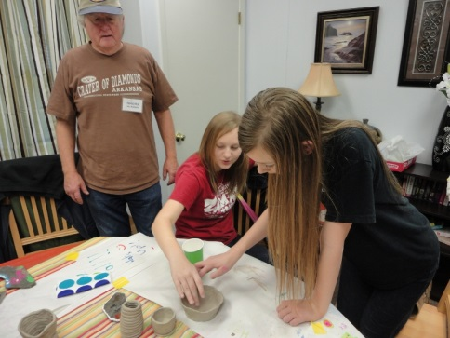
Page 3 NMGMS PO Box 1445 Tupelo, MS 38802

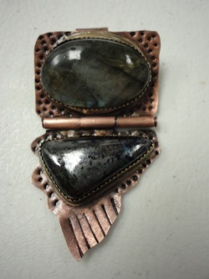
Mysteries of "Stone Hinge" Revealed, by Clarice Turner The Nugget: Volume 14 Issue 9

Once upon a cold January time, in Tupelo, Mississippi, an adventurous and excited group of North Mississippi Gem and Mineral Society members gathered at The Women First Center to unlock the mysteries of “Stone Hinge”. No, not Stonehenge, the mystical prehistoric stone monoliths in Wiltshire, England, but something full of intricate details and techniques that we were all anxious to learn more about. This "Stone Hinge" is a specially designed copper pendant project by the well-known jewelry artist, Kim St. Jean. She and her husband, Norm, accepted our club's invitation to present this workshop; sharing and demonstrating some of her jewelry making skills, as illustrated in her two books, Mixed Metal Mania and Metal Magic. Kim's studio and home are in Myrtle Beach, South Carolina. They spend much time during the year traveling and teaching classes at bead shows, lapidary schools, studios, and clubs, like ours. This is her second workshop with our group.

Amid the loud Crosstown train whistles, we checked out Norm's large collection of gemstones, supplies, and tools that were available for purchase. Kim had a display of her many finished copper, bronze, and silver necklaces, bracelets, and rings. We all selected two gemstones for our own Stone Hinge, and chose a workstation, which was complete with tools and a soldering mat. Then, it was time, time to listen, watch, and learn to unlock the mysteries of Stone Hinge. Nancy Roberts, our club president, made introductions and announcements. Kim began our workshop by reviewing pickle pot and “LOS” basics. The “pickle” is a warm acid solution that removes fire scale and flux impurities, and the warm Liver of Sulfur (LOS) solution gives the finished metal piece a nice antique glow, after the dark gray color is polished with fine steel wool.

Next, Kim showed us how to design our Stone Hinge project, by using paper, pencil, and glue. This design would be used as a guide, while cutting or sawing the 24gauge copper sheet, the base for our pendant. After that came the tube hinge, requiring more sawing, and some soldering. Kim demonstrated that technique, and reminded us to pickle and rinse. Next came the toughest technique of the day, making the bezel, which is a thin strip of metal that holds a stone in place. Sounds simple enough, and was easy for some. I was still on the first part of that, soldering the ends together, when I noticed Mike Schuchs had already soldered his bezel to the base, and was trying the stone for a good fit. He gave us ladies, at his table, a few helpful tips and we kept at it, hoping for a tight fit. It was about this time, that we all detected delicious aromas coming from the kitchen area. Thanks so much to Floy Hawkins, a past club president and a club founder, for preparing a gourmet style lunch for us, and to Ann and John Byzet for helping to serve and take workshop pictures.

At this point in our workshop, we began to get anxious to see how our gemstones would look on our Stone Hinge. But, we had the third main step to go, the "turtle tab" setting, which many of us had practiced last year in Kim’s workshop. This prong piece of copper was to be sawed, sanded, and then riveted onto the bottom portion of our pendant. The prongs, or turtle arms, would be folded over to hold our smaller gemstone in place. After that, we cut a strip of copper for a bail, which was textured and sanded, before riveting it to the back of the upper portion. Ready to put in the stones? No, not yet! We had to texture, file, sand, pickle, rinse, and “LOS” the piece. Now, we were ready. Stone time! Well, this important time was reached at different intervals, because, we each worked at different speeds. Some finished early, and some finished after the sun had long set. But, we can all say, we learned a lot. Loretta Hettler commented that she definitely felt more confident using the saw and Mike said he was headed straight home to his workshop to do another similar project. Nikki Kenney said that those who had taken the class last year were getting better and much more comfortable this time at torch firing. We all "oohed" and "aaahed" as we saw each piece finished. Pride floated on the air, and Nancy took pictures of our beautiful Stone Hinges; each one different and unusual.

Did we unlock the mysteries of Stone Hinge? With Kim's patience, guidance, and demonstrations, yes, we did. It took extra saw blades, and extra time on the bezel portion, but our finished pendants were unique, creative, and worth the time and effort. And so, the NMGMS workshop attendees lived happily ever after in their home workshops, with creative designs floating from head to hands, to hammer to saw, to torch to pickle pot. From just this one Stone Hinge workshop, there will be well-known jewelry artists showing their creations at club meetings and shows, and maybe giving a workshop or two. Watch for them!
Page 4 Photo of Justin’s Stone Hinge by Nancy Roberts

Kim St. Jean Teaches NMGMS Members Another Fantastic Mixed Metals Class! The Nugget: Volume 14 Issue 9
Comments by attendees:

Susan Curry "... I had a good time at the class, though everything I did took about 6 tries to get it right. The sawing was the worst, just because I have no manual skills beyond writing (maybe cooking). The food was great, by the way and kudos to those fixing it. I look forward to another workshop..."

Mike Schuchs: "I had a wonderful time. There were too many ah ha moments to count. I will need to set up my work station here and practice, to figure out what the next questions are. The food was good. The fellowship was excellent. It was a day well spent."

Sarah Harris: "Love, loved the class and went home all pumped up! I would like to repeat the techniques we learned with another similar piece. I believe I might benefit from the repetition.... there was so much to learn in so short a time. .... after I got home, I had to work at getting my shoulders down from my ears!"

Loretta Hettler: "We sure had some beautiful creations. ......right now I need practice in sawing and soldering. ..."

Nancy Roberts: "Wow, what a fabulous class, lots of new techniques to learn and some others to gain more practice on. We had a great group of participants, so it was a lot of fun and Kim is such a great teacher, so thorough, yet relaxed and interesting. Already looking forward to next year's class; what new creations will we make next?"

Nikki Kenney: "I thoroughly enjoyed the class and was so glad that Kim was able to stop again to teach this project for us. I hope that she can continue to do these classes for our club. By having a teacher who can come to us, learning these mixed metals techniques becomes more accessible to a larger number of club members. Kim is an excellent teacher; what we learn in her class sticks with us, so it can be applied to other projects that we do on our own."

Photos by Nancy Roberts

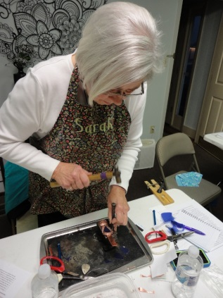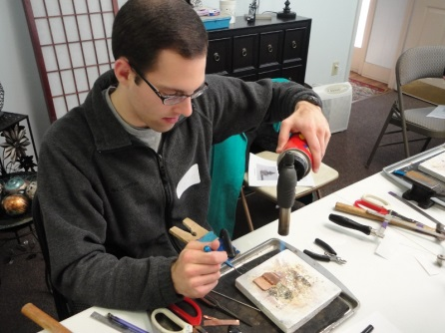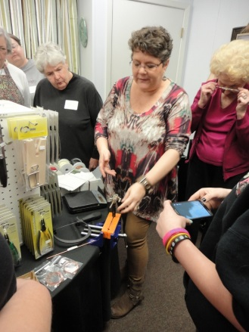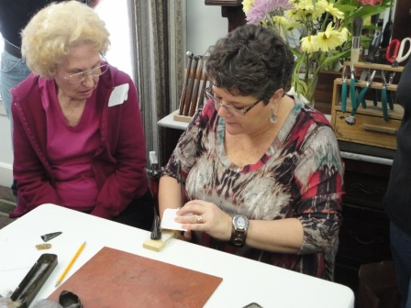
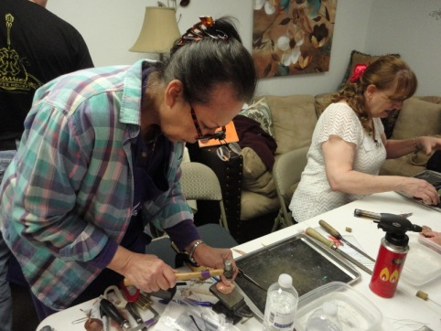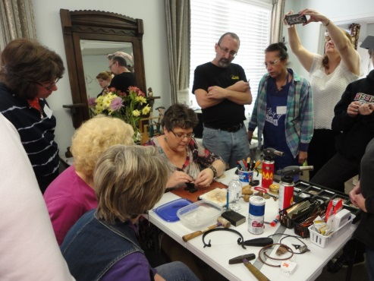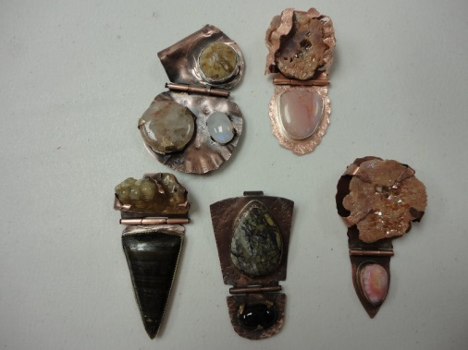 Page 5
NMGMS PO Box 1445 Tupelo, MS 38802 www.nmgms.org

Safety: The Nugget: Volume 14 Issue 9

Day Hiking Essentials by Belinda Loyd

Right now, with young children and busy schedules, trails that can be hiked in the same day, often called day hikes, are preferred. While day hikes don’t require the necessary preparation and gear that an overnight hike requires, being prepared is important.

Hiking Shoes: The most critical element of a successful day hike is good hiking shoes. Many inexperienced people will tell you that a good pair of tennis shoes will do fine. Well, that depends on the terrain. Many trails are wet at this time of year and have lots of large rocks and fallen trees. This is particularly true when visiting a wet area, which proposes two unique issues:
- Tennis shoes get wet – and hiking with wet feet is a great way to get sick, and end the hike with really sore feet.
- Wet rocks and fallen trees are slick – Falling and breaking a bone or busting your head open when you’re out on a trail, and then another 10 – 15 miles from the nearest medical assistance isn’t an ideal situation. Rocks along trails and fallen trees are slick.
Purchasing a good set of non-slip, water proof hiking boots or hiking shoes is money well spent, in order to avoid both of the issues above, and for numerous other reasons. Whether you get shoes or boots really doesn’t matter, the choice is really all about personal preference. I prefer boots due to: Better ankle support – important when traversing rocky terrain and Taller – They keep dirt, rocks, and water out of the inside of your boot. The downside to boots, of course, is that they are more bulky and a little heavier.

Clothing: For summer hiking, a decent pair of shorts and a t-shirt will suffice, but isn’t optimal. Something many people forget to consider when hiking is that it rains often and unexpectedly. Rain storms can come up out of the blue and soak you. Standard cotton clothing does not do well in these conditions, hiking back to the car in wet underwear, shorts and shirt, is not a pleasurable experience. For winter hiking, cotton can literally mean death. It’s cold and a rain storm suddenly shows up, soaks you, and you’re miles away from your car, your clothes can freeze, resulting in hypothermia, and possible death. The best way to solve both of these issues is to wear non-cotton, “quick dry” moisture wicking clothing.

Day Pack: Appropriate shoes and clothing are the most important and essential items for a hike, but there are other things like food, water and supplies you’ll need to carry along with you. You’ll need something to carry all of this gear in, which is when a lightweight day pack fits the bill. Everyone generally carries 2-3 bottles of water, spare clothes and whatever other items they want to bring, like small cameras, iPods, etc. Kids seem to prefer simple gym sacks.

Food and Water: Staying hydrated and keeping your energy levels up while on the trail is critical, even while on a short day hike. This is particularly true during the warmer summer months where humidity levels and temperatures can be high. Many of the creeks and streams can look crystal clear, but don’t be tempted to drink the water. Don’t risk drinking it straight from the creek. If you want to drink creek or stream water, always boil it first for 20 minutes or more. Personally, I’ve never done this, so bring your own. Just not worth getting sick over.
Some great snacks to carry with you: Mountain Trail Mix, Snickers Bars, Peanut Butter Crackers and Beef Jerky. All of these are full of protein and sugar, two very important ingredients when hiking. The snickers bars of course are really bad for you, but come in really handy on longer hikes when you start to run low on energy. Store all of the food in Ziploc bags, so the smell doesn’t attract any wildlife. Also bring an extra Ziplock bag to store any trash or wrappers for the same reason. (Cont. on pg 7)

www.nmgms.org Page 6 NMGMS PO Box 1445 Tupelo, MS 38802

Day Hiking Essentials, cont. The Nugget: Volume 14 Issue 9

Camera Backpack: One thing we’ve learned is NEVER forget your camera. Smaller cameras pack great in your day pack wrapped up in a Bandana.

Other Important Items: Carry a few other items that I’ve learned (the hard way) to bring:
- Toilet Paper/Tissue – In a small Ziplock bag, we carry both tissues and some toilet paper. Don’t leave it on the ground like many people do; bring an extra zip lock bag to put your used toilet paper in.
- First Aid Kit – We’ve never had to use one, but have used it for other people and children while on field trips.
- Bandanas – When hiking, you really just can’t have enough of these. We carry 4 with us, and end up using all 4 every single time. They are great for controlling sweat, as napkins, for cleaning off gear, good to eat on to keep from spilling items, and the list goes on…
- Rain Ponchos – After being soaked, for the past two years on a field trip, we’ve started carrying rain ponchos with us.
- Pocket Knife – Like Bandanas, the uses for a small lightweight pocket knife are endless. I never hike without one.
- 2 Bic Lighters – On a day hike, you’ll most likely never need these, but just in case. Why 2? In case one doesn’t work.
- Sunscreen – Protect yourself from the sun, especially when hiking in open areas.
- Flashlight – Flashlight on a day hike? Well, consider this – You under estimate how long it will take you to get back or you get a bit lost. Night time starts to set in, and you’re still a long way from your car. There are no lights on the trails. Always carry two flashlights, just in case. One as a backup.

Wrapping Up; One of the biggest mistakes that inexperienced hikers make is, not being properly prepared. When hiking, you must realize that even when you are day hiking, you may be in a remote and wild area. Know that:
- You are in a remote area.
- You will get hungry and thirsty
- You may get hurt
- You might get lost
- The hike might take longer than you expect
- You might get wet
- The weather could change, dramatically.
Considering all of these things, you definitely want to be prepared. There are many other items to consider, but these are what is consider the essentials for a day hike. Belinda Loyd

www.nmgms.org Page 7 NMGMS PO Box 1445 Tupelo, MS 38802

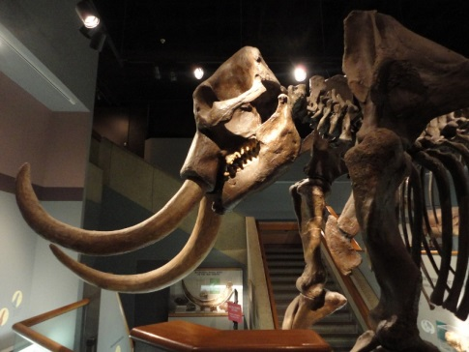
The Nugget: Volume 14 Issue 9
Pink Palace Museum Review
On Feb. 7, 2015 the Rockheads visited the Pink Palace Museum in Memphis. Here is a review of that trip:
Marion Carr:
“I liked the dinosaurs and the big buffalo. I especially liked the escalator! I also liked the dresses. The Piggly Wiggly store was interesting, but you couldn’t buy any of the groceries there. The people (manikins) scared me. I liked the frog pond place and rolled the balls into the holes”.
Jake Carr: I liked the games upstairs and the grocery store. You had to pull the lever back on the frog and it throws a ball into the hole. I liked lots of dinosaurs, T-rex and some of the bones. They had an ancient human bone”.
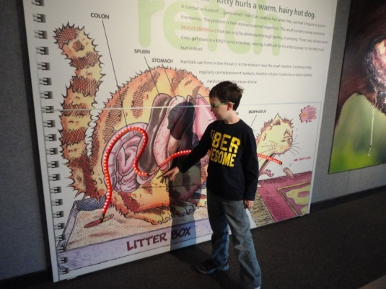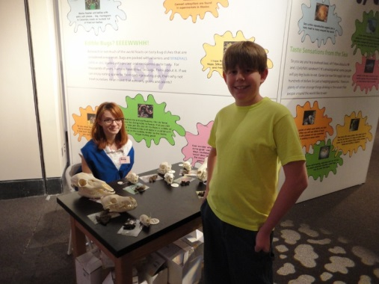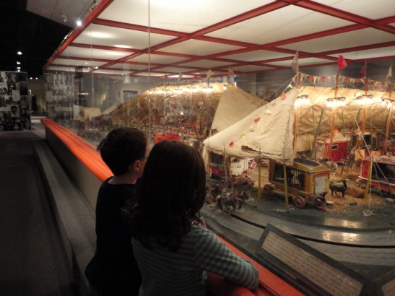
Photos by Nancy Roberts
NMGMS Committee Chairperson:
Cheryle Langford has volunteered to be our NMGMS historian. She will take over working on the club yearbooks. So anything that you have from 2014 that should go into our yearbook, please be sure and turn it in to Cheryle. Thank you Cheryle!
Cheryle Langford
121 Willow Creek Rd
Saltillo, MS 38866
662-869-2278
cherlang7@att.net

www.nmgms.org page 8 NMGMS PO Box 1445 Tupelo, MS 38802
The Nugget: Volume 14 Issue 9
Minutes for NMGMS Board of Directors Meeting
January 17, 2015
Time and Place
The regular meeting of the Board of Directors of the North Mississippi Gem and Mineral Society was held on Saturday, January 17th from 12:30 to 1 p.m. at the Women First Center in Tupelo. The meeting was called to order by the president of the club, Nancy Roberts.
Members Present
Members present were Nancy Roberts, Nikki Kenney, Roger Lambert, John Byzet, and Brenda Manning.
Approval of Minutes
Previous minutes were presented and approved.
Treasurers Report
The treasurer presented a balance of $2,769.33.
Committee Reports
Roger Lambert presented new information regarding Scout revisions. These changes will be available in book form by May/June of this year. Promoting ways for Scouts to earn badges was also discussed.
Unfinished Business
No unfinished business.
New Business
Nancy suggested that the club donate $50 to Women First in lieu of purchased staples, such as, tissue, soap, etc. Motion approved.
Nancy also asked for board approval to award a mini scholarship to Justin Hobart for the Kim St. Jean class, if also approved by the membership at the regular meeting. Motion approved.
Details discussed for Geology Day and club picnic. This is pending discussion with Rae Mathis at Oren Dunn. We will finalize these dates later.
Possible club workshop in February with more information later; We have not had a call back on our West Point class, so that is pending.
Regular club meeting February 21st will be held at Women First Center and features a wire wrapped heart as our project. Adjournment : Meeting was adjourned at 1:pm Brenda Manning, Secretary

www.nmgms.org page 9 NMGMS PO Box 1445 Tupelo, MS 38802
The Nugget: Volume 14 Issue 9

NMGMS MEETING MINUTES Date: January 17, 2015
Pledge of Allegiance to the Flag was led by everyone. Guests of Justin Hobart, Amanda and Ashley were introduced, and the November 2014 meeting minutes, as printed in the Dec. Nugget, were approved …
Chairpersons Reports Treasurer’s Report: Closing Balance of $ 2,769.33 Field Trips: The next scheduled field trip will be the week of spring break (March 7 th and 8th) to Potosi, MO for drusy quartz. Members decided to reserve accommodations at Rosener’s Motor Lodge, 573-431-4241 at $35 per night, which includes 2 queen beds. Other area attractions: Missouri Mines State Historic Site and museum, Elephant Rocks State Park, Johnson’s Shut-Ins State Park, and historic Ste. Genevieve on the river, known as the oldest town in Missouri.
Publicity: Check our Website and Facebook page. Post club flyers locally and in outlying areas. Membership: 114 Total members for 2014. 2015 Dues: $12 per person--$20 for family Hospitality: Dana Armstrong and Cheryle Langford are responsible for refreshments in February. Brenda Manning and Alison Schuchs have March. The Byzets will get the birthday cake for March Website: Check us out at www.nmgms.org Newsletter: Reviewing begins on issues of the 2014 Nugget for submissions into 2015 competition. Deadline for newsletter submissions is the second Friday of each month. nuggeteditor@gmail.com Nancy handed out the 2014 Bulletin Competition awards and certificates to the winners.
Youth Members: The Rockheads are working on Stone Age Tools and Arts FRA badge and are making clay pots. Stamps: The SFMS has decided to drop the stamp program. Historian: Cheryle Langford is the new club historian. We are gathering items for the yearbook. Geology/Kids Day: We will be meeting with the Oren Dunn Museum to set a date for our next Geology Day. Safety: Members were asked to submit a short safety article for the Nugget each month.
OLD BUSINESS: The board had voted to award one mini scholarship for the Kim St. Jean Mixed Metals class on Jan. 24, 2015. The membership approved, and the scholarship was awarded to Justin Hobart.
NEW BUSINESS: dues to the Southeast Federation for 2015, of $199.50 have been paid. No one was available to attend the SFMs quarterly meeting in Panama City on Jan. 24th.
The February 21st NMGMS meeting will be held at the Women First Center, 215 N Gloster, Suite D, in Tupelo from 1 to 3. The program will be a wire wrapped heart.
There’s a Copper Bangle Workshop Saturday, Feb 14th, from 10 am til 4 also at Women First Center. Kit fee is$5. Bring your lunch!
Reminder: 2015 NMGMS membership dues are due!! MGMS rock and gem show at the fairgrounds in Jackson on Saturday, Feb. 28th and 29th. Motion to Adjourn…….

www.nmgms.org page 10 NMGMS PO Box 1445 Tupelo, MS 38802

