Volume 14 Issue 10 March 15, 2015

www.nmgms.org

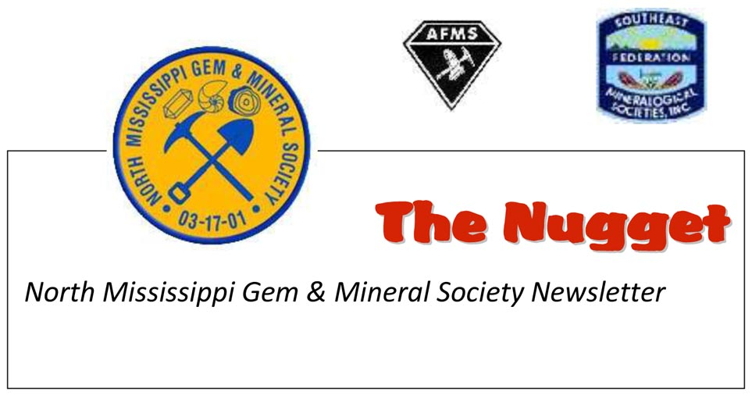

Notes from the President’s Desk…..March 2015

Happy St. Patrick’s Day and Happy 14th birthday NMGMS! Finally, all of the snow has melted and my daffodils are blooming. We just got back from a really fantastic and fun trip of collecting drusy quartz over in the old lead mining district of Missouri. According to the loads of rocks in the beds of 4 pickup trucks, it was a good haul! Our most sincere thanks go to area resident, Betty Marler, for being such a gracious and fun field trip guide for the weekend. At 83, she can still get out there and collect as much as the rest of us!

Our 2015 membership roster continues to grow, and as of my last count, we have 90 members to date. If this keeps up, this will turn out to be our best membership year yet! We still have a few members who haven’t renewed, so I hope that they will consider all that NMGMS has to offer, and renew soon. Don’t forget our birthday meeting coming up on March 21st. I encourage everyone to bring something to display. Let’s share with our fellow members and guests, what we have collected or accomplished over the past year. It’s always fun and exciting to see what each of us brings and it doesn’t have to be rock related. If your talents lie elsewhere, please bring something to show. We have such a very talented and diverse group of members, so let’s show everyone what “gems” we really are! I know the Rockheads have some projects that they can display too. They’ve been working really hard on the FRA badges lately. I can’t wait to see what everyone brings!!

It looks like we are going to have a full class at our April 11th West Point Copper Bangle Workshop. At last count, we only had 2 seats open, so if you’re still interested, please let me know soon. Our club calendar is filling up on into June, so it is time for us to start looking at what we would like to schedule for our fall field trips and meeting programs. If you have any ideas or suggestions, drop them off to either me, or Roger Lambert. Be sure to check out the calendar of events section of the newsletters, or our website (www.nmgms.org) to see what events we have lined up for each month. It looks like we have a fun filled year ahead of us!

Nancy Roberts

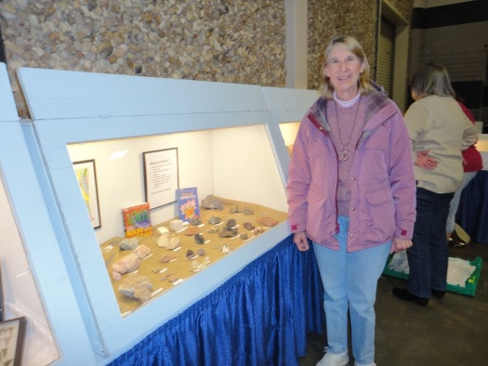 Nancy setting up displays at the MGMS show, by Floy Hawkins

Page 1 NMGMS PO Box 1445 Tupelo, MS 38802

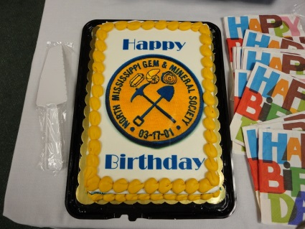Mark Your Calendar! The Nugget: Volume 14 Issue 10

Notice of the next club meeting: Happy 14th Birthday NMGMS!

The NMGMS **March 21, 2015**meeting will be held at the Lee County Library from 1 to 3p.m.

It's our 14th birthday party!

This is the time when we “show off” what we have been working on over the past year.

All members are asked to bring in something to display.  It can be a part of your rock, mineral or fossil collection, your lapidary/ bead work or just something interesting that you may have picked up in your summer travels. If your talents lie elsewhere, please bring something to show; whatever it is you like to do. We’re always interested! This is your chance to “shine” and share with everyone your interests, talents and expertise!

**Attention all Rockheads!!  Please bring your displays, too.  Remember, doing a display at some point during the year, counts towards the "Junior Rockhound of the Year" award that NMGMS gives out at the Dec. meeting.**

**Note:**

We will also hold our “Brown Bag” silent auction at this meeting.  Members are asked to bring two items, each one packaged in its own brown paper bag.  One item is to be a “nice” rock and gem related item (not absolute) and the other item can be silly, funny or cute, (kind of “white elephant”) but no garbage, please!  These bags will be set out on the table for silent bidding during the meeting.   We have always had some really nice surprises and this is lots of fun, especially with the younger members!

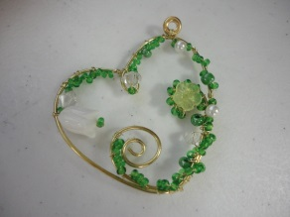**Volunteers for the refreshments are: Alison Schuchs and Brenda Manning.  Ann Byzet is bringing the cake.**

***Anyone who worked on the wire heart project at the February meeting and didn't get a chance to finish it, bring it along to the March meeting and if you need some help, we'll try to work on it.

Upcoming events:

On April 11, 2015, NMGMS members will be teaching a copper bangle workshop in West Point, MS for the West Point/Clay County Arts Council.

NMGMS will be holding their annual picnic and rock swap on **April 18, 2015** starting at 1p.m. at the large pavilion in Ballard Park, West Main St., Tupelo, MS.

For more details concerning these events, visit our website at: [www.nmgms.org](http://www.nmgms.org)

Page 2 NMGMS PO Box 1445 Tupelo, MS 38802

The Nugget: Volume 14 Issue 10

Valentine’s Day Workshop

The NMGMS copper bangle workshop was so much fun and a great success. Everyone managed to complete their bangle, plus a pair of dangle earrings and a washer ring. The happy sound of clanging hammers got us started singing “I’ve been working on the railroad…”, and we all enjoyed seeing how unique everyone’s pieces turned out. Lots of oohs and ahhs were heard, when someone showed their finished ring or earrings. We’ve got a very talented bunch of members in our club! Those who were new had so much fun, that they went out and bought all of the necessary equipment in order to continue making jewelry with their newly learned skills. Well done!! Nancy Roberts

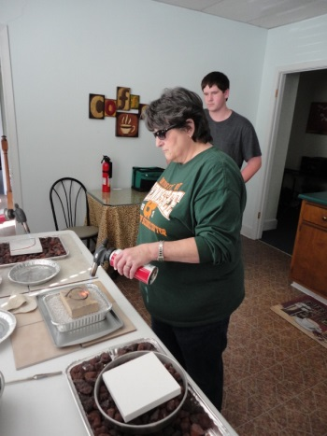 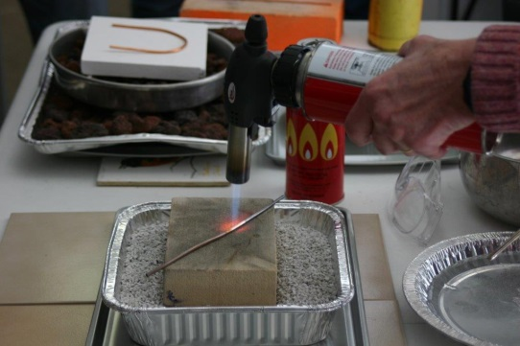 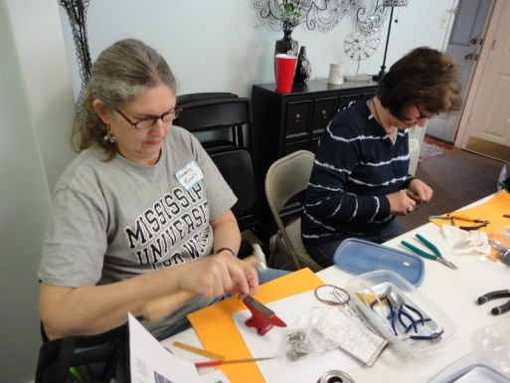 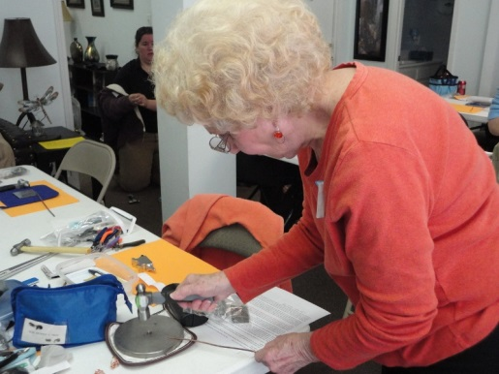 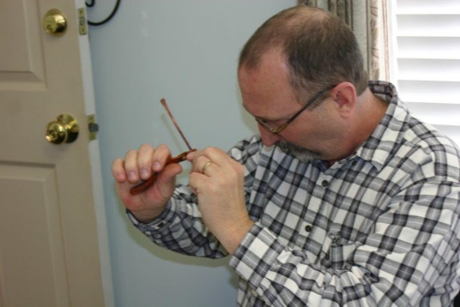 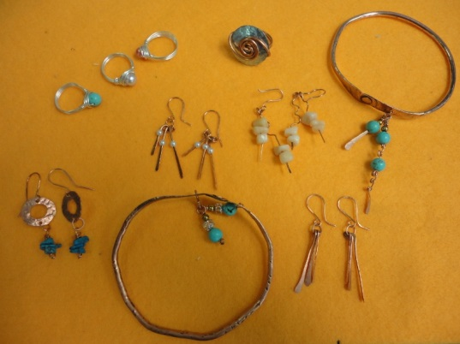

Join NMGMS now…you don’t want to miss any of these exciting workshops!!

**Attention Fellow NMGMS Members!**

2015 is here and it's almost time for our March birthday meeting.  It is time to plan on renewing your NMGMS membership. You may renew anytime between now and our birthday meeting on March 21st.  Our club treasurer will be available to collect your dues at the meeting, or you can make checks payable to NMGMS ($12 single, $20 family) and mail them along with an application form to:

 NMGMS, P.O. Box 1445, Tupelo, MS 38802 .    Form is available on the website: [www.nmgms.org](http://www.nmgms.org)

***Please consider renewing; we appreciate your membership and NMGMS has a lot to offer you!

After the March meeting, if you haven't renewed your membership, you will be dropped from the club's email roster. :(...

Page 3 NMGMS PO Box 1445 Tupelo, MS 38802

The Nugget: Volume 14 Issue 10

Rockheads: February 2015 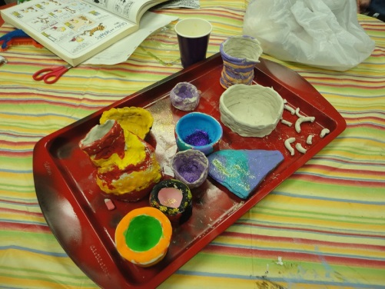

On Feb. 21st, the Rockheads painted the pots that they made at the last meeting. We talked about field trips and places that we wanted to visit. Jake, Alice and Mary played a wind up fishing game.

Rockheads meeting attendees: Victoria Langford, Konrad Armstrong, Matthew and Brittani Lambert, Jake, Marion, and Alice Carr.

They planned their May field trip and hot dog cookout to Twenty Mile Creek.

New business: Visit a museum with rocks, in Jackson?

Submitted by Brittani Lambert, Secretary

While the Rockheads were painting, the rest of the club members were playing with wire!

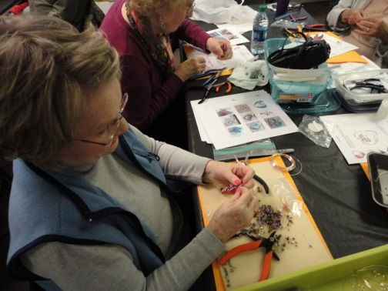 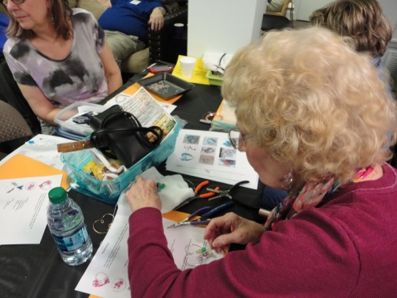 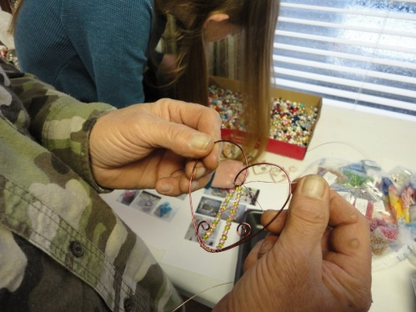

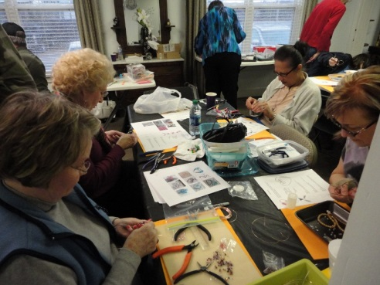 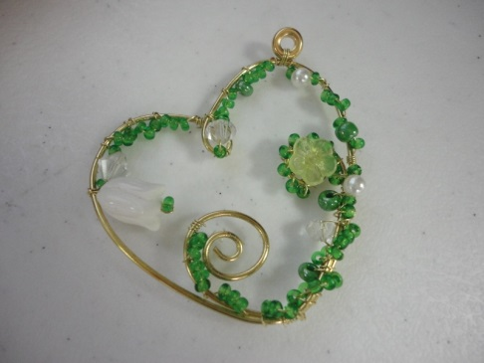 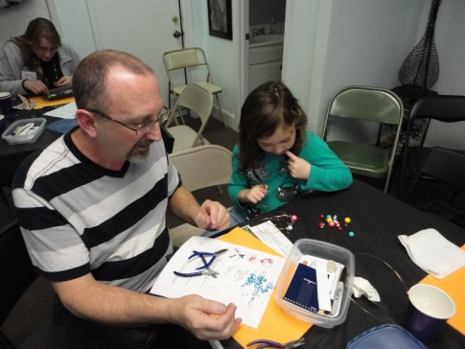

Page 4 NMGMS PO Box 1445 Tupelo, MS 38802

The Nugget: Volume 14 Issue 10

Upcoming NMGMS Class:

The West Point/Clay County Arts Council is hosting another wonderful day of jewelry design with the North MS Gem & Mineral Society out of Tupelo .

Copper Bangle Workshop!

Want to make some really neat copper bangles using heavy gauge copper wire?  Learn to anneal, paddle the wire, texture and rivet, as you work your way to making some really nice bangle bracelets.  We'll also work on a pair of earrings made with paddled copper wire and beads. We can throw in a cool ring project too, with large gauge copper wire and a hardware store washer.  See the attached photos for a look at some finished pieces.

**When**:  Saturday, April 11, 2015 **Where**: Louise Campbell Center for the Arts, 235 Commerce St.,   West Point MS **Time**:  10 to 4 **Class fee**: $40

 Bring a brown bag lunch! Class is limited to 15, so please let us know if you plan to attend.

 Contact Souzen Steelhammer, (souzendeavers@aol.com) Nancy Roberts, (therockhoundlady@yahoo.com) or Kathy Dyess,(kathydyess@bellsouth.net) with questions or to let us know that you want to join us.   Feel free to call Souzen at 494-7288 or Kathy at 494-5678 if you're here in town and want to be in touch that way.

Again, we are asking that if you plan to come, please mail a check for $40 to:  Souzen Steelhammer, 2252 Cedars, West Point, MS  39773, so that we receive it before Friday, April 10th.

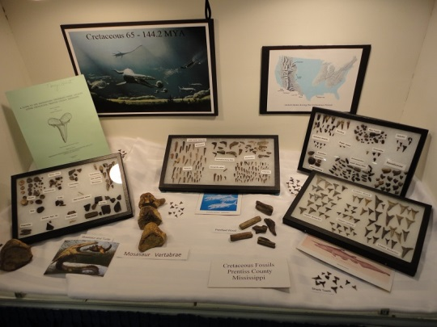MGMS 2015 Rock and Gem Show

The Mississippi Gem and Mineral Society’s rock and gem show was held at the fairgrounds in Jackson, MS on Feb. 28th and March1st this year. Floy Hawkins and I went down on Friday, Feb. 27th to set up a couple of displays and to help out where needed. We enjoyed having time to visit with our sister club members and renew old friendships. It was a delight to see so many NMGMS members show up on Saturday for the show; I know they had a great time visiting all of the vendor tables and making many interesting purchases. This show really has some fantastic dealers and is always fun to attend.

Since Twenty Mile Creek is one of our favorite collecting sites in Mississippi, I choose to take down my display of fossil shark teeth and other specimens that I collected from that site. I always enjoy putting together these displays and it’s a great way to share your interests with the public. Hopefully they learned something from my display and will become excited about fossil collecting in their area. I thank MGMS for providing the display cases and the opportunity to participate in their show. I will start planning for next year, that’s for sure!!

Nancy Roberts

|  |
| --- |
|  |

Page 5 NMGMS PO Box 1445 Tupelo, MS 38802

www.nmgms.org The Nugget: Volume 14 Issue 10

Another great show is coming soon….

 Don’t miss it!!

NMGMS will be setting up an exhibit/club information table again at the Memphis show, so if you are planning to attend, consider helping out at the club’s table. Thanks!

 Bead Soup! By Nancy Roberts

After struggling with my first attempt at soldering on a bezel, I hold a deep respect for those who have mastered this technique. I came across a very informative article by Lexi Erickson, “5 Essential Soldering Rules”, originally published in Lapidary Journal Jewelry Artist magazine, May/June. 2011.

So basically, Lexi has 5 “rules” to follow that I have condensed here, remember these 5 things and you should have great success with your soldering applications.

1. Fit: Your pieces must fit together; solder will not fill gaps.
2. Clean: Your metals should always be very clean. Solder won’t adhere to dirt or oils. Once clean, do not .handle the surface, where you will solder, with your fingers.
3. Flux: Flux will keep your joint clean and will help prevent fire scale.
4. Placement: Place your solder carefully, remembering that solder follows heat.
5. Heat: Keep your torch moving and gradually heat up your piece. Gentle, don’t rush!

Remember to heat the larger metal pieces first; this will save many a melted bezel!

This is an excellent article, so check out the Lapidary Journal Jewelry Artist magazine today; they’re all great issues!! This magazine is published by Interweave Press, LLC. For more great tips by Lexi Erickson, check out her complete collection of articles in Lapidary Journal Jewelry Artist “How to Solder Jewelry”, available online at <http://www.interweavestore.com/jewelry/jewelry-magazines>. You’ll be glad you did!

Page 6 NMGMS PO Box 1445 Tupelo, MS 38802

**2015 Officers** The Nugget: Volume 14 Issue 10

President/Field Trip Chair:

Nancy Roberts

25 Amber Lane

Counce, TN 38326

(731)689-5336

therockhoundlady@yahoo.com

Vice-President:

Roger Lambert

1817 CR 7002

Corinth, MS 38834

(662)286-3750

roger.lambertjr@yahoo.com

Secretary:

Brenda Manning

77 County Road 864

Dennis, MS 38838

662-454-3128, 662-279-0706

b.man.55@hotmail.com

Treasurer:

Nikki Kenney

PO Box 808

Tupelo, MS 38802

662-844-6142

ofkbk@comcast.net

**Appointees**

Historian:

Cheryle Langford

121 Willow Creek Rd

Saltillo, MS 38866

662-869-2278

cherlang7@att.net

Stamp Chair:

Dana Armstrong

494 Wildwood Rd.

Holly Springs, MS 38635

662-268-0143

darmstrong@shsm.org

Publicity Chair/Web Master

John Byzet

1209 Queensgate Dr

Tupelo, MS 38801

(662)844-9841

wa4jax@comcast.net

Membership:

Ann Byzet

1209 Queensgate Dr

Tupelo, MS 38801

(662)844-9841

annbyzet@comcast.com

Hospitality:

Rebecca Vallarian

308 Meadowbrook Circle

Armory, MS 38821

(662)256-2040

janiegirl@vallarian.com

Nugget Editor:

Dana Jones

1868 HWY 310

Waterford, MS 38685 [nuggeteditor@gmail.com](mailto:nuggeteditor@gmail.com) Page 7 NMGMS PO Box 1445 Tupelo, MS 38802

The Nugget: Volume 14 Issue 10

**NMGMS MEETING MINUTES** Date: February 21, 2015

Pledge of Allegiance to the Flag was given, new member Christy Paul was introduced, and the Dec.,

2014 meeting minutes were approved.

**CHAIRPERSONS REPORTS**

**Treasurer’s Report**: Closing Balance of $ 2,837.70.

**Field Trips:** The next scheduled field trip will be the week of spring break (March 7th and 8th) to

Potosi, MO, for drusy quartz. Members decided to reserve accommodations at Rosener’s Motor Lodge.

Other area attractions were discussed. Reggie Bolton from Birmingham club has issued invitations to

their February field trip. Open to club members only. Handouts available if interested.

**Publicity**: Robert Langford set up a photo shoot with his Twenty Mile Creek fossil identification

station for an article by Melony Crown which should be available mid March in a Tupelo magazine.

Rebecca is setting up the “Rocks for Food” exhibit at the Amory library for the month of March.

Volunteers were requested to make up a club flyer for distribution.

**Membership**: 2015 Dues: $12 per person--$20 for family. Total members for 2015 so far is 71.

**Hospitality**: Alison Schuchs and Brenda Manning are responsible for refreshments in March. Ann

Byzet will get the birthday cake.

**Website:** Check us out at www.nmgms.org

**Newsletter**: Reviewing begins on issues of the 2014 Nugget for submissions into 2015 competition.

Deadline for newsletter submissions is the **second Friday** of each month. nuggeteditor@gmail.com

Nancy handed out the 2014 AFMS Bulletin Competition awards and certificates to the winners.

**Youth Members:** The Rockheads are working on Stone Age Tools and Arts FRA badge and are

making clay pots.

**Stamps**: The SFMS has decided to drop the stamp program.

**Historian**: Cheryle Langford is gathering items for the yearbook.

**Geology/Kids Day:** We will be meeting with the Oren Dunn Museum to set a date for our next

Geology Day.

**Safety:** 17 members need to sign liability waiver. Monthly safety articles needed.

**OLD BUSINESS**:

1. We need grab bags and specimens for our next Geology Day.

2. Decision pending as to the location of our annual picnic scheduled for April 18th.

3. Club will participate in New Albany show 2nd week of June. Particulars of this later.

**NEW BUSINESS**:

1. March 21, 2015 is our birthday meeting and will be held at the Tupelo Library from 1 to 3p.m.

Members requested to bring in something to display and share. Also bring “brown bag” items for a

silent auction.

2. Dave Hanes has volunteered to set up at the MMNS Fossil Road Show and represent our club.

3. Pat Arinder will be presenting his Stone Age Tools program at our May 16th meeting at the Tupelo

Library

4. NMGMS will be teaching the copper bangle class in West Point on April 11th for the Clay County

Arts Council. Fee is $40 and seating is limited to 15 students.

**Motion to Adjourn…….**

**www.nmgms.org**

Page 8 NMGMS PO Box 1445 Tupelo, MS 38802